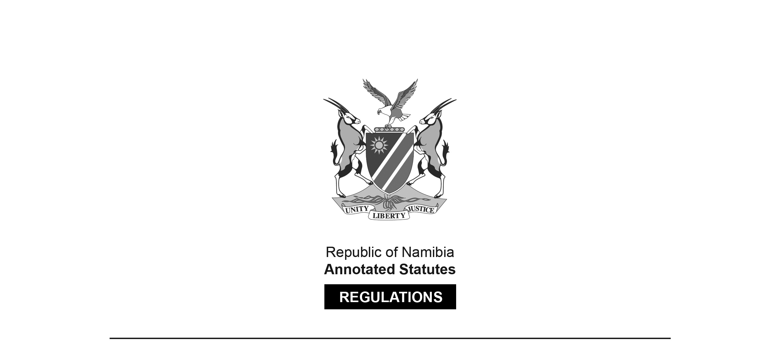

RULES SURVIVING IN TERMS OF

Reciprocal Enforcement of Maintenance   
Orders Act 3 of 1995

section 13(2)

Rules made in terms of section 9 of the Reciprocal Enforcement of Maintenance Orders Act, 1963

RSA Government Notice R.299 of 1971

([RSA GG 3002](http://www.lac.org.na/laws/GGsa/rsagg3002.pdf))

came into force on 1 March 1971 (RSA GN R.299/1971)

These rules were initially made in terms of section 9 of the *Reciprocal Enforcement of Maintenance Orders Act 80 of 1963* which wasrepealed by the Reciprocal Enforcement of Maintenance Orders Act 3 of 1995. In terms of the transitional provision in section 13(2) of the Reciprocal Enforcement of Maintenance Orders Act 3 of 1995, these rules are deemed to have been made under section 12 of that Act. Note that rule 5 withdraws the rules in RSA GN R.98/1965 ([RSA GG 1011](http://www.lac.org.na/laws/GGsa/rsagg1011.pdf)).

**ARRANGEMENT OF RULES**

[These rules have no headings.]

*Rules*

**1.** In these rules, unless the context otherwise indicates

“Act” means the Reciprocal Enforcement of Maintenance Orders Act, 1963;

“maintenance officer” means a maintenance officer appointed or deemed to have been appointed under section 3 of the Maintenance Act, 1963 (Act 23 of 1963);

and a word or expression to which a meaning has been assigned in the Act shall bear that meaning

**2.** Registration of any maintenance order referred to in section 3 of the Act shall be effected -

(a) by entering the particulars of such order, including the date when and place where and the name of the proclaimed country in which the order was made, in a register kept for the purpose of the registration of maintenance orders, as defined in the Act or in any other law, at the maintenance court to which a copy of the order was transmitted under the said section; and

(b) by posting by registered post to the person against whom such order purported to have been made, at his last known address, a notice calling upon him to effect payment in terms of the said order to the clerk of the maintenance court concerned at the time and place specified in such notice.

**3.** (1) Subject to the provisions of the Act and any rules made thereunder, the procedure and rules of evidence, including the competency, compellability, examination or cross-examination of witnesses, to be followed at or in connection with an enquiry under the Maintenance Act, 1963 (Act 23 of 1963), shall, in so far as they are appropriate and can be applied, *mutatis mutandis* apply to enquiries under section 4(3) of the Act.

(2) Any certified copy of a provisional maintenance order or depositions of witnesses or any statement referred to in section 4(1) of the Act shall on its mere production by the maintenance officer at an enquiry under section 4(3) of the Act be admissible in evidence.

(3) Notwithstanding anything to the contrary in any law contained, any document purporting to be signed by a judge or an officer of a court in a proclaimed country shall, unless the contrary is proved, be deemed for the purposes of an enquiry held under section 4(3) of the Act, to have been signed by a judge or an officer of such court without authentication of the signature of or proof of the office held by the person purporting to have signed such document and any officer of such court by whom a document is purported to have been certified shall, unless the contrary is proved, be deemed to be a proper officer of the court for the purposes of so certifying such document.

**4.** The rules relating to appeals and cross-appeals, prescribed under the Maintenance Act, 1963 (Act 23 of 1963), shall *mutatis mutandis* apply to appeals under section 4(4)(a) of the Act.

**5.** Government Notice R.98, dated 22 January 1965, is hereby withdrawn.